[SE113.P11] Exercise: BlackBox & WhiteBox

1. Bài 1: State diagram => Test case

* Bảng dịch chuyển trạng thái:

|  |  |  |  |  |  |  |  |
| --- | --- | --- | --- | --- | --- | --- | --- |
|  | E1 | E2 | E3 | E4 | E5 | E6 | E7 |
| S1 | S2 |  |  |  |  |  |  |
| S2 |  | S2 | S3 |  |  |  |  |
| S3 |  |  |  | S1 | S4 | S4 |  |
| S4 |  |  |  |  |  |  | S1 |

* Các test case:

|  |  |  |  |
| --- | --- | --- | --- |
| No | Trạng thái hiện tại | Sự kiện | Trạng thái tiếp theo |
| 1 | Chờ để mua hàng | Nhập vào các mặt hàng | Nhập các mặt hàng khách đã chọn |
| 2 | Nhập các mặt hàng khách đã chọn | Nhập tiếp | Nhập các mặt hàng khách đã chọn |
| 3 | Nhập các mặt hàng khách đã chọn | Kết thúc nhập | Chờ thanh toán |
| 4 | Chờ thanh toán | Thanh toán thẻ tín dụng | Kiểm duyệt thẻ/séc |
| 5 | Chờ thanh toán | Thanh toán bằng séc | Kiểm duyệt thẻ/séc |
| 6 | Chờ thanh toán | Thanh toán tiền mặt | Chờ để mua hàng |
| 7 | Kiểm duyệt thẻ/séc | Xử lý kết quả | Chờ để mua hàng |

1. Bài 2:

* Flow diagram:

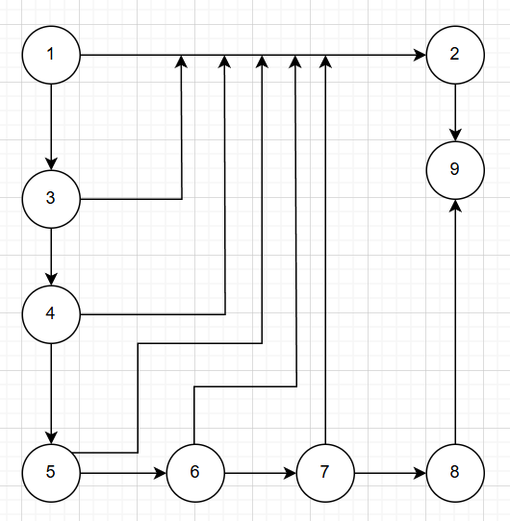

* Complexity = 7
* Paths:
  + 1-2-9
  + 1-3-2-9
  + 1-3-4-2-9
  + 1-3-4-5-2-9
  + 1-3-4-5-6-2-9
  + 1-3-4-5-6-7-2-9
  + 1-3-4-5-6-7-8-9
* Testcases:

|  |  |  |  |  |
| --- | --- | --- | --- | --- |
| TC | Input | | | Output |
| x | y | z |
| 1 | 0 | 1 | 2 | 0 |
| 2 | 3 | 0 | 1 | 0 |
| 3 | 3 | 2 | 0 | 0 |
| 4 | 2 | 1 | 3 | 0 |
| 5 | 2 | 3 | 1 | 0 |
| 6 | 2 | 1 | 3 | 0 |
| 7 | 4 | 5 | 6 | 1 |

1. Bài 3: Decision table

|  |  |  |  |  |  |  |  |  |
| --- | --- | --- | --- | --- | --- | --- | --- | --- |
| **Conditions** | **Rule1** | **Rule2** | **Rule3** | **Rule4** | **Rule5** | **Rule6** | **Rule7** | **Rule8** |
| Orphan or dependent of court? | Y | N | N | N | N | N | N | N |
| Both parents are alive and married? | - | Y | N | N | N | N | N | N |
| Widowed or single parent? | - | - | Y | N | N | N | N | N |
| Remarried widowed/single parent? | - | - | - | Y | N | N | N | N |
| Parents divorced or separated? | - | - | - | - | Y | - | - | - |
| Lived with which parent more? | - | - | - | - |  | Parent A | Y | N |
| Parent lived with remarried? | - | - | - | - |  | Parent B | N | - |
| No parent, receive financial support? | - | - | - | - |  | - | - | Y |
| Live with grandparent or guardian? | - | - | - | - | - | - | - | - |
| **Action** |  |  |  |  |  |  |  |  |
| Skip Step Four | X |  |  |  |  |  |  |  |
| Answer about both parents |  | X |  |  |  |  |  |  |
| Answer about widowed/single parent |  |  | X |  |  |  |  |  |
| Answer about widowed/single parent & spouse |  |  |  | X |  |  |  |  |
| Answer about parents living with more |  |  |  |  | X |  |  |  |
| Answer about parents who lived with more & spouse |  |  |  |  |  | X |  |  |
| Answer about parents providing most support |  |  |  |  |  |  | X |  |
| Answer about grandparents or guardian |  |  |  |  |  |  |  | X |

* Test case

|  |  |  |
| --- | --- | --- |
| ID | Condition | Expected Result |
| 1 | The user is an orphan or dependent/ward of the court | Skip Step Four |
| 2 | Both parents are alive and married to each other | Answer questions about both parents |
| 3 | Parents are widowed or single | Answer questions about the widowed or single parent |
| 4 | Widowed or single parent has remarried | Answer questions about the widowed or single parent and their current spouse (stepparent) |
| 5 | Parents are divorced or separated | Answer questions about the parent the user lived with more during the past 12 months |
| 6 | User lived with one parent more, and that parent has remarried | Answer questions about the parent the user lived with more and their current spouse (stepparent) |
| 7 | User did not live with one parent more than the other but received financial support from one parent | Answer questions about the parents who provided the most financial support |
| 8 | User lives with a grandparent or guardian instead of a parent | Answer questions about the grandparents or guardian |